User Manual for the Marion Program
Selecting a term - double click with the left button on a word from the database in the left part, alternatively you can use the selection by clicking the mouse and pressing ENTER, or drag the word with the mouse using the left button. The word appears in the "Selected Terms" section, which represents the active "bowl" for use with the connected EAV instrument.
Deleting a term from the "Selected Terms" section - double click with the left mouse button
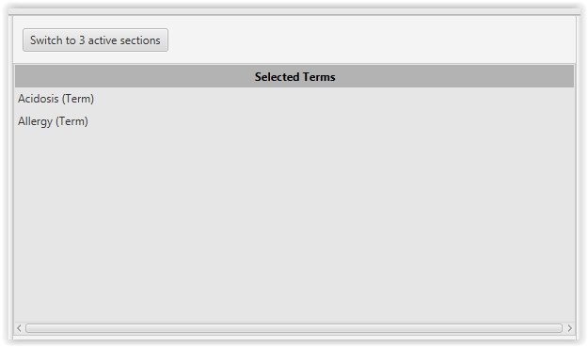
Selecting a preparation - double click on the preparation in the right section with the left mouse button, alternatively you can select it by clicking the mouse and pressing ENTER, or drag the word with the mouse using the left button.

The "Selected Terms" can be switched to the three active areas display mode by clicking the "Switch to 3 active sections" button for easier orientation. Once switched, the active area is divided into three parts, each of which is a full-fledged and active "bowl" for inserting expressions and slides.
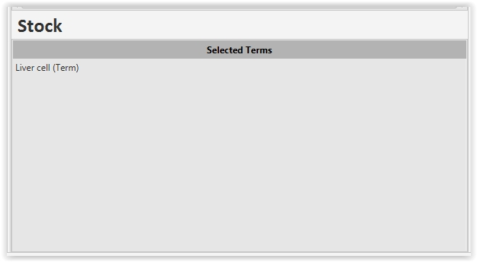
Stock - a word can be dragged here only from the "Selected Terms" active area by using the left mouse button; alternatively, you can use the right mouse button and select the "Move to Stock" menu. You can delete an expression by double-clicking the left button.

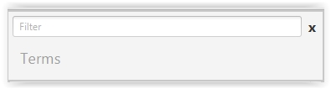
Search - to search, you can use the line with the word "Filter" located above the section you want to search in. Just enter a part of the search word and the system will search the entire database of stored terms or preparations. To clear the search, press the cross next to the search bar.

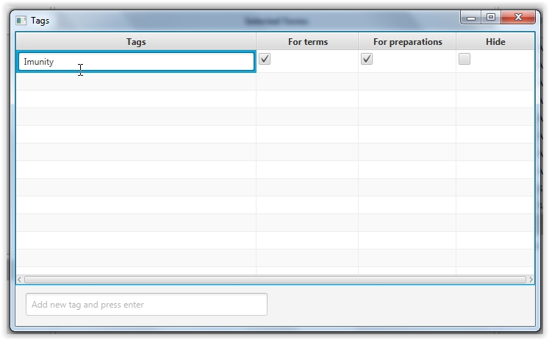
Tags - the tags function can be used to store the most commonly used terms and preparations. In the "File" menu, select the "Tags" option - a window will appear in which you can create new Tags to which you can later assign your chosen terms or preparations. Type the name of the new tag in the "Insert new tag and press enter" line, press enter. For the newly created expression, we can check the option whether the tag will be displayed in the section for terms and in the section for preparations. Checking the "Hide" option will hide the tag and therefore it will not be displayed on the main page.

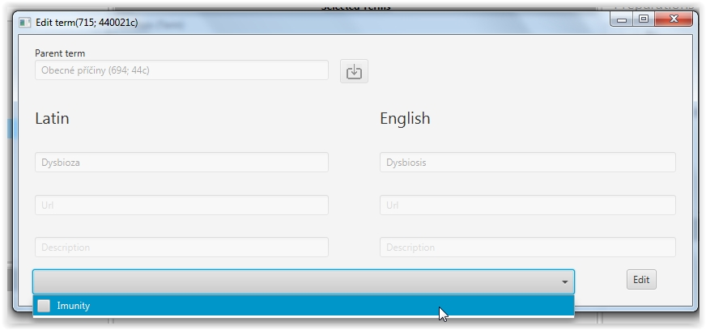
To assign an expression to the newly saved tag, right-click on the desired term and select "Edit". A table with the details of the expression will open. In the bottom part, left-click in the row next to the Edit button - the list of saved tag names will expand - select the tag you want to save for the given term and confirm with the Edit button.
To use a tag, just left click on the desired name in the Tags section of the home screen and only the words associated with the selected tag will be displayed. To cancel the display of these words, just double-click on the tag name again with the left button.
The same procedure is followed in the right section with the saved preparations.
Saving measurements - for easier orientation in the chosen detoxification procedure of the client, we can save the result of each measurement. This can be done by selecting "Save" from the top menu "Saved measurements". A table will appear in which fill in the name of the client, or another name of the measurement and notes. All terms and preparations that are in the "Selected terms" section (bowl) and in the Stock at the time of saving will be saved to the record.
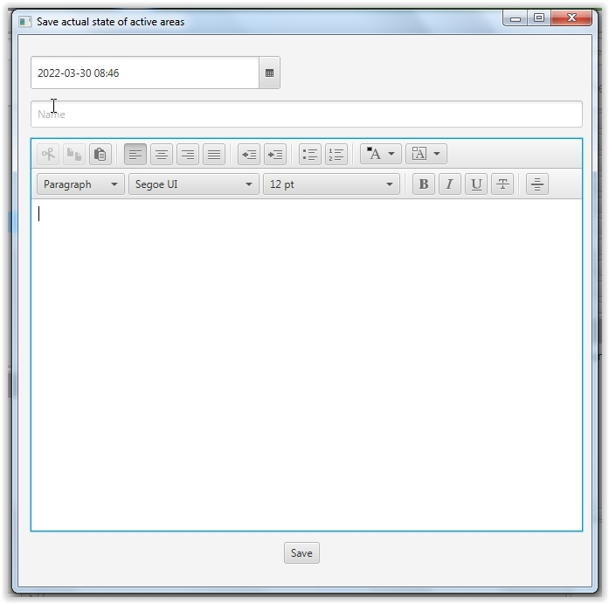

To reload the measurement result of the given case, open the "Saved measurements" menu in the top menu bar and select "Load". The saved measurements are sorted by date and time. For easy searching, just type the client's name in the top row labelled Name and the system will search and display all measurements with the client's name. Of course, you can also use the calendar if you are looking for a specific date. Then just left-click on the desired record and confirm with the Load button at the bottom. In case you want to delete the saved record, click on the delete button on the right side of the saved record row. This operation deletes the saved record permanently and cannot be restored in any way!
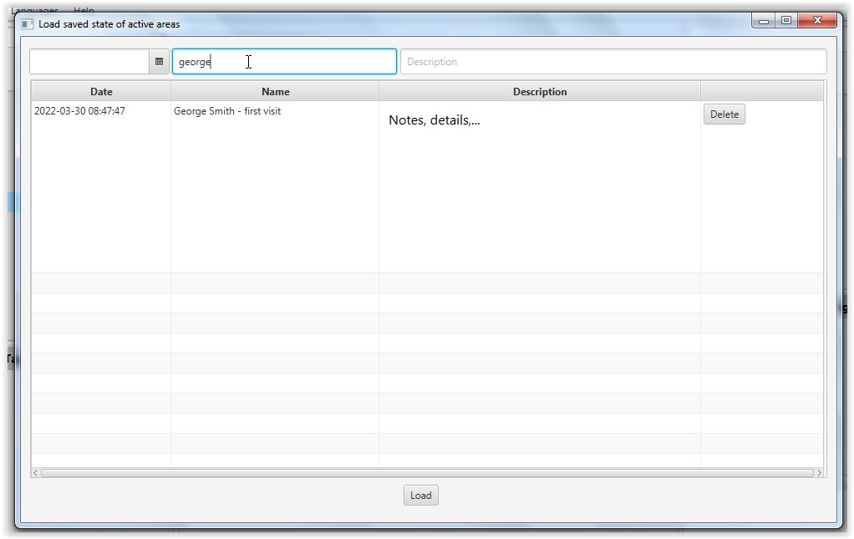
Backup - we recommend that you make a backup of the database at least once a week, which saves all the user modifications that the user has made in the program. These are mainly saved measurements and tags created. To create a backup, select the File - Setting button in the top menu bar. In the newly opened window, click on the Backup tab at the top. Here we can choose the name of the backup file and the path where the backup will be saved. Finish the backup by clicking the Create backup button. It is recommended to make a backup to a different disk than the one on which we have the diagnostic program installed (preferably e.g. to a flash drive or external disk). In case of a computer failure or loss of e.g. a laptop, all user data stored at the time of backup creation can be fully restored from this backup.
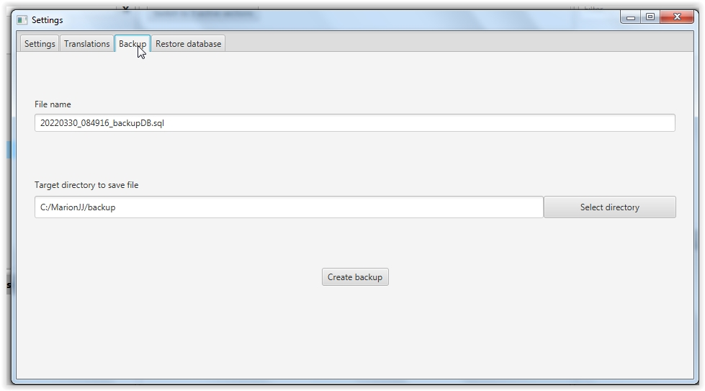

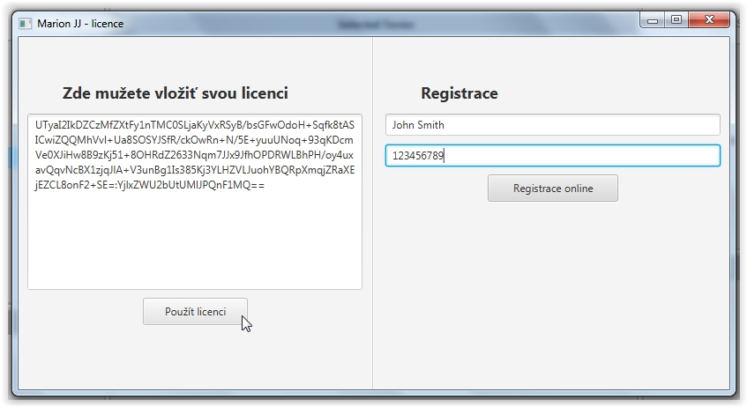
License renewal - press the Help - License button in the top menu bar to display a table with information about the validity of the license. Before the end of the period, just press the Renew License button and a table will pop up, in which you can generate a new license using the procedure described in the program installation (Online registration - after generating the key - Use license).
Preparation details - for easier orientation in the preparations, you can use the Preparation detail menu, which can be called by right-clicking on the given preparation.
