Instructions for the Installation of the Marion Diagnostic Program
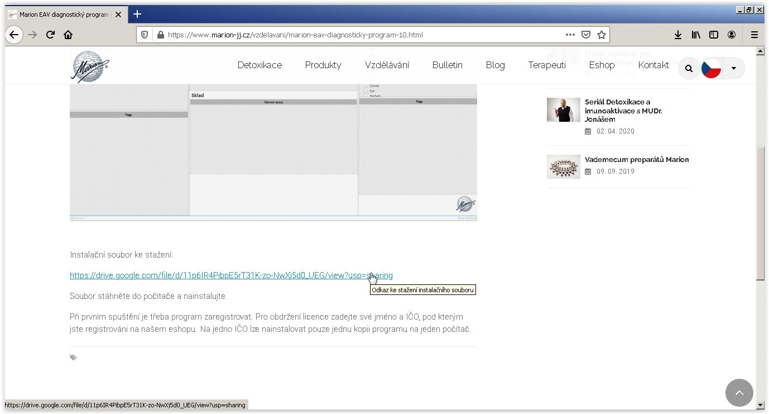
- Download the "marionjj_setup_2100906-0944.exe" file to your computer. The link is available on the Marion website in the Education section - link: https://www.marion-jj.cz/vzdelavani/marion-eav-diagnosticky-program-10.html

- The "No preview available" box with the "Download" button will appear - click on it.
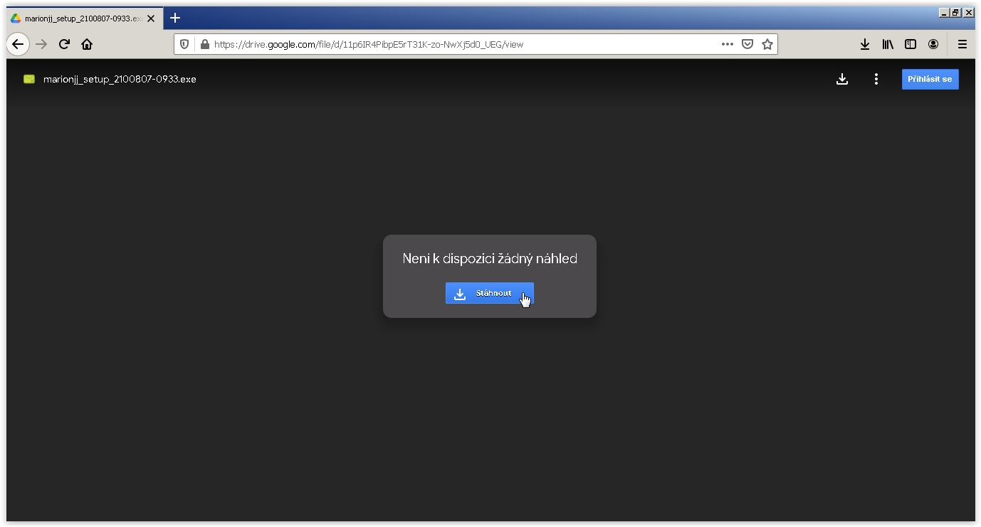

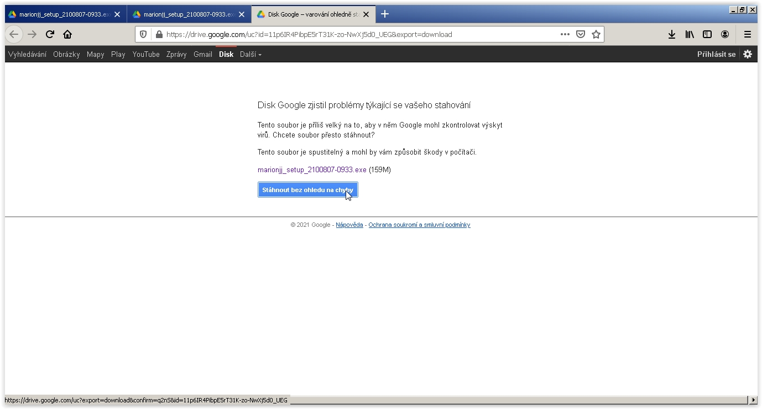
- The "Google Drive has detected problems with your download" table will appear - press the "Download regardless of errors" button.
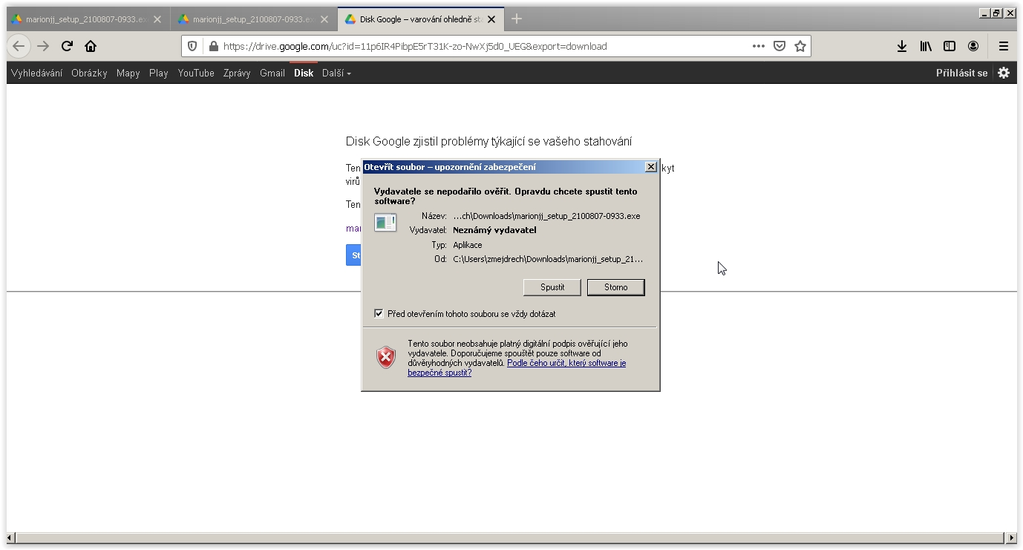
4. Run the file from the download location (typically the Downloads folder) - double click on the downloaded file, the "Open File - Security Warning" table will pop up; press the Run button here.
5. The "User Account Control" table will pop up; click on the Yes button here.
6. To accept the license agreement, check the box next to "I accept the agreement"; click on the Next button.
7. Choose the name under which the program will be listed in the Menu; if you don't want to change anything, click on the Next button.
8. Choose whether to create an icon on the desktop and in the quick launch; if you don't want to change anything, click on the Next button.
9. Finally, start the installation by pressing the Install button. A table showing the information regarding the installation process will appear.
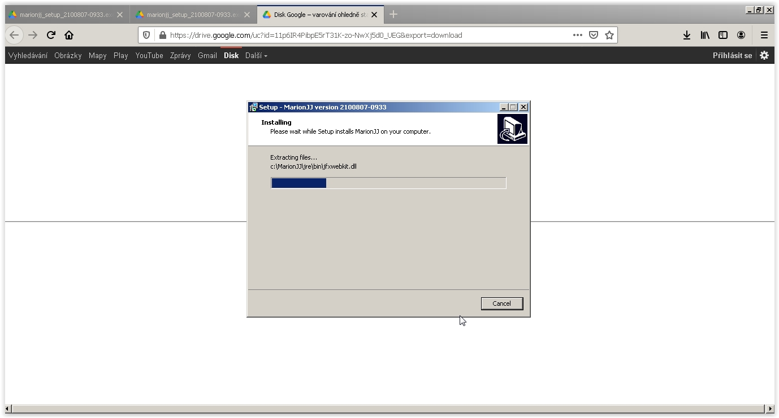
- Finish the installation by pressing the Finish button
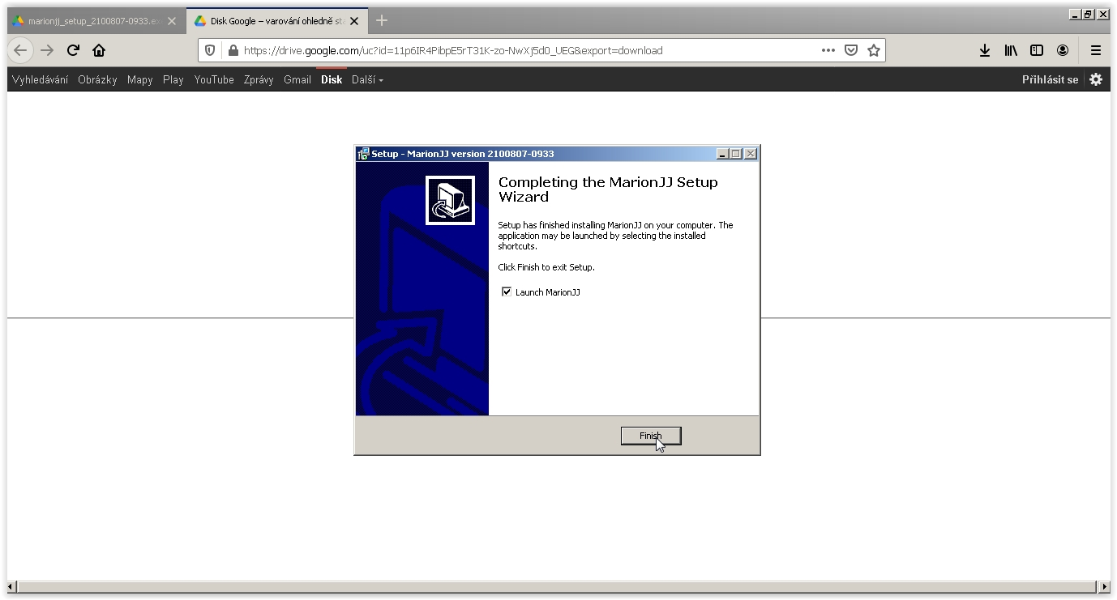

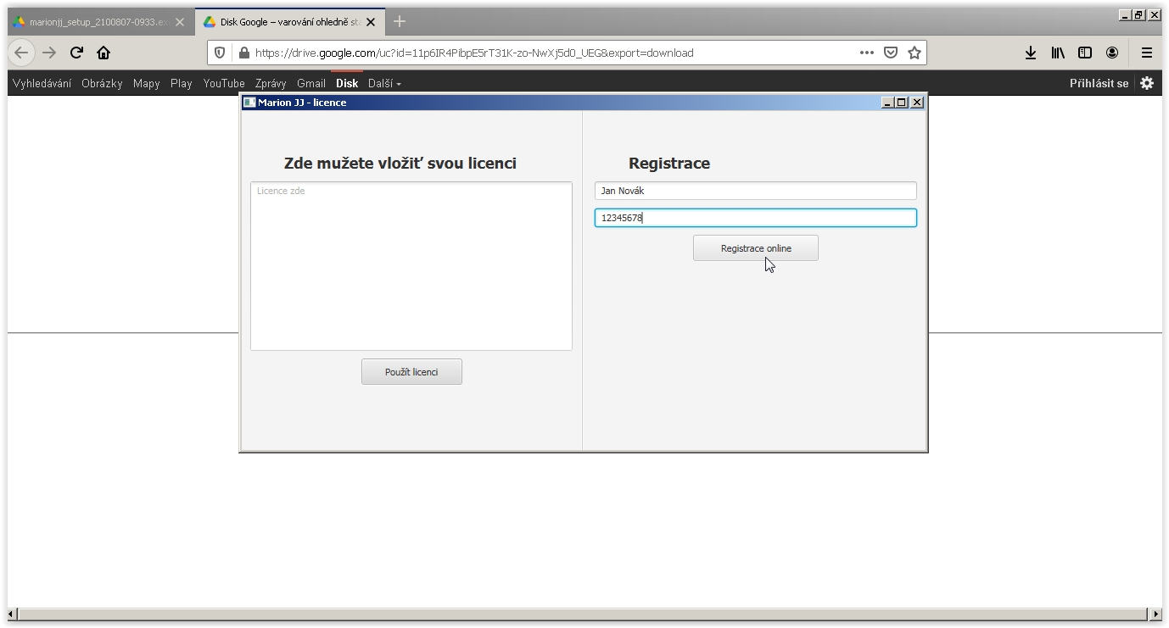
- The table for inserting the Marion license will appear. To receive the license, enter your name and the Company Registration Number (IČO) under which you are registered in our e-shop. Only one copy of the program can be installed on one computer under one Company Registration Number. Once completed, press the "Registrace online" (Online Registration). You must have an active internet connection to register!!!

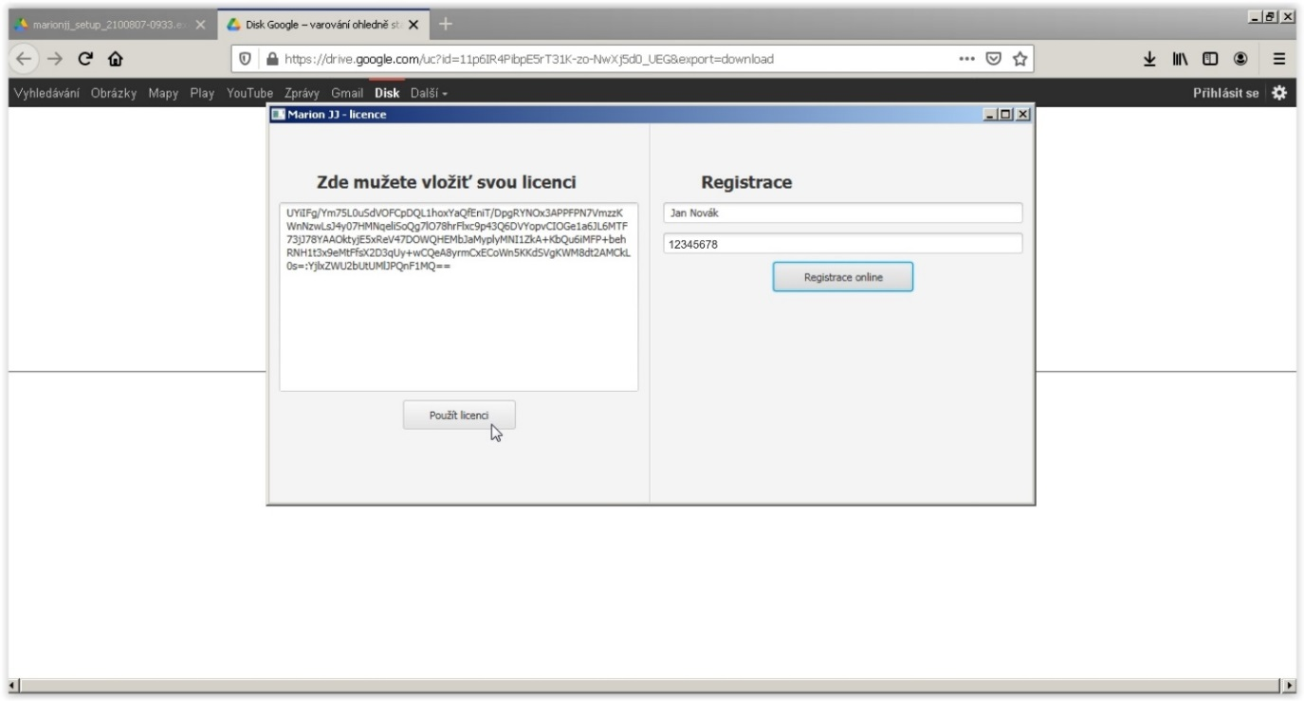
- If you have filled in a correct Company Registration Number (IČO) that has not yet been registered, a few lines of characters - the license key will appear on the left side of the screen with the "Zde můžete vložit svou licenci (You can enter your license here)" heading; press the "Použít licenci (Apply the license)" button.

- The Marion programme will open and it is possible to start using it.

